What is rolling shutter?

A roller shutter is a type of door or window shutter consisting of many horizontal slats (or sometimes bars or web systems) hinged together. The door is raised to open it and lowered to close it. On large doors, the action may be motorized. It provides protection against wind and rain.

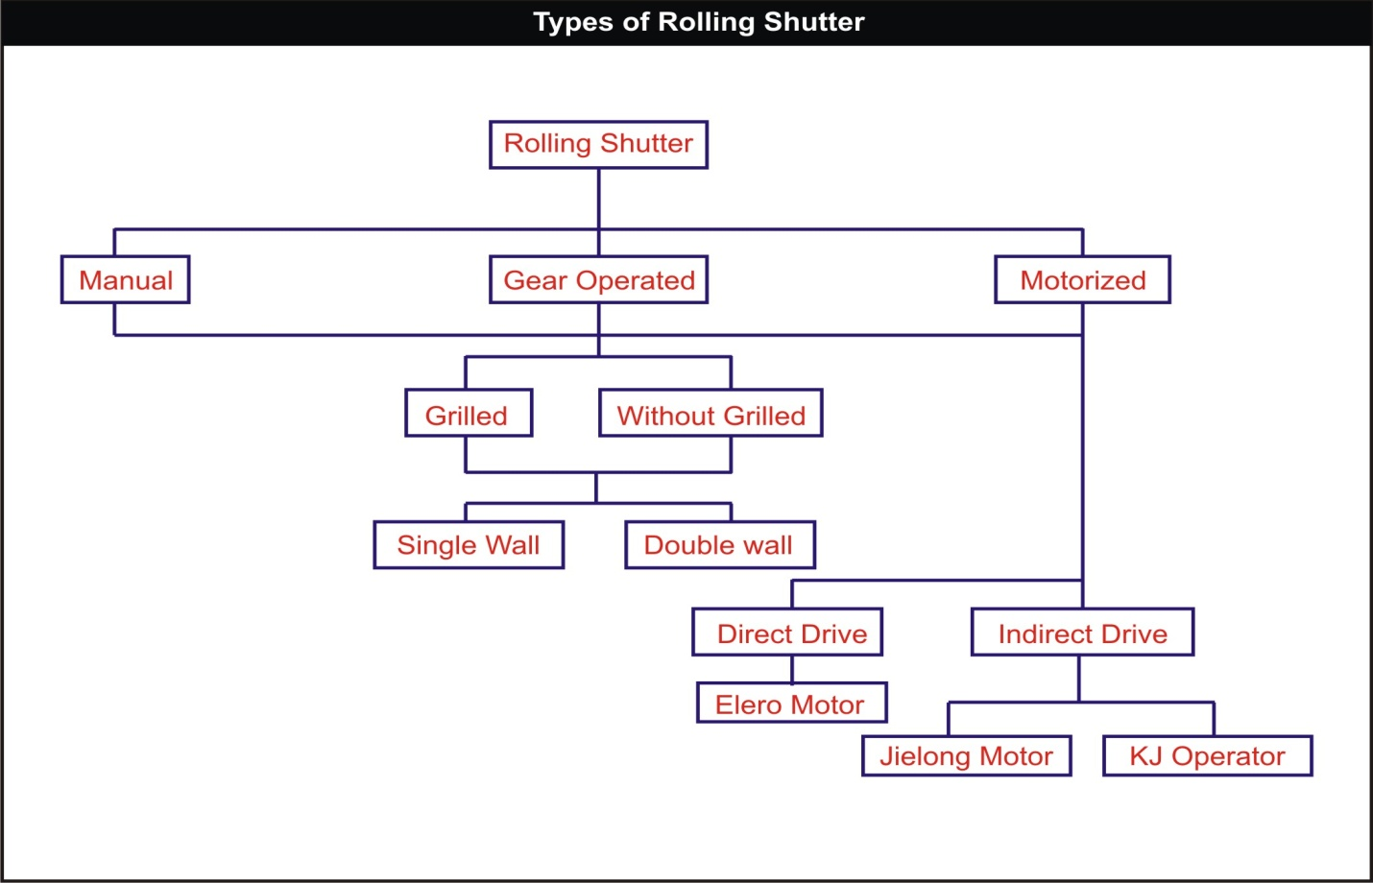

Design data sheet for
Motorized rolling shutter

Important part of rolling shutter:-

1. Lath or slat -The individual rolled interlocking laths or slats with which the rolling shutter curtain is assembled.
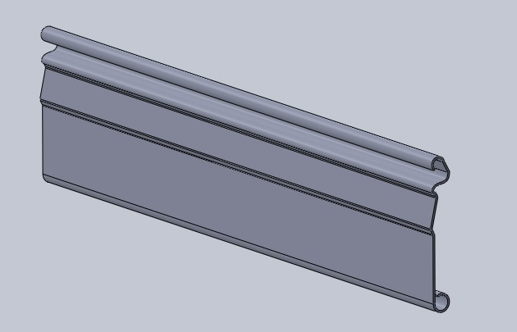

2.Bottom Lock Plate - The fabricated bar inserted at the bottom of rolling shutter curtain, so as to lie against the sill, including the slide bolts, Pulling handles, etc.

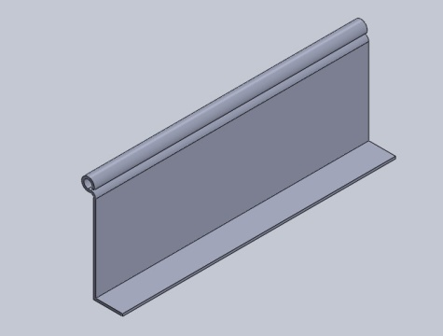

3. Bracket Plates -The supporting plates at either end on the top, together with the U-shaped clamps supporting the entire moving mechanism of the rolling shutter.
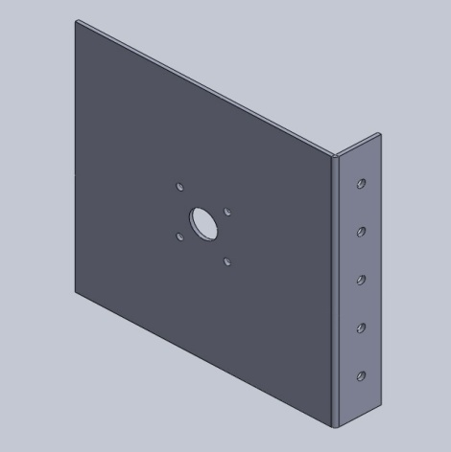
4. Guide Channels -- The channels on either side in which the shutter moves up and down.

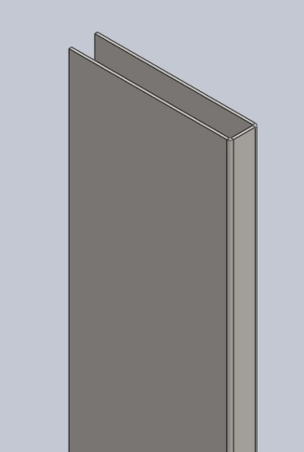

5. Hood Cover - A sheet metal cover bent into a suitable shape for covering the roller.

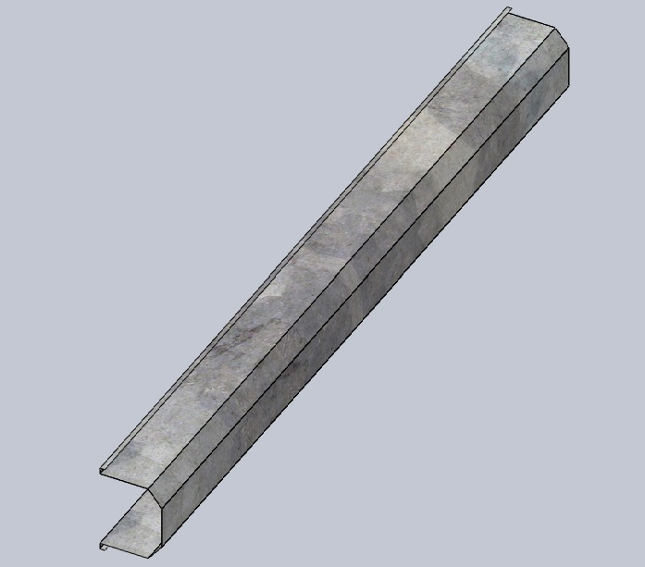

6. A) Pipe shaft – It is main shaft on which curtain rolls.

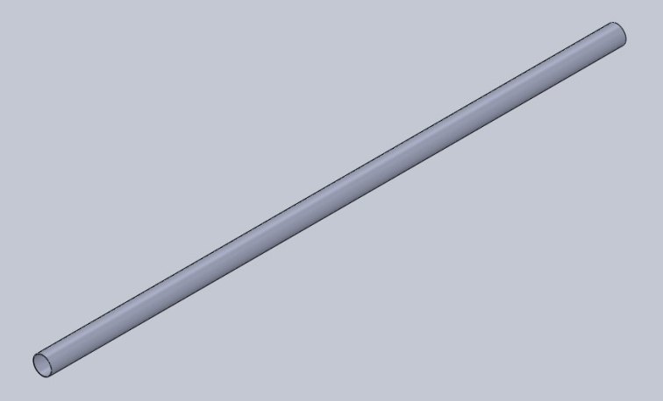

b) Flange shaft- It is shaft having two circular plates out which one will remain in pipe
Shaft for safety in case of failure and other will be welded on pipe shaft.

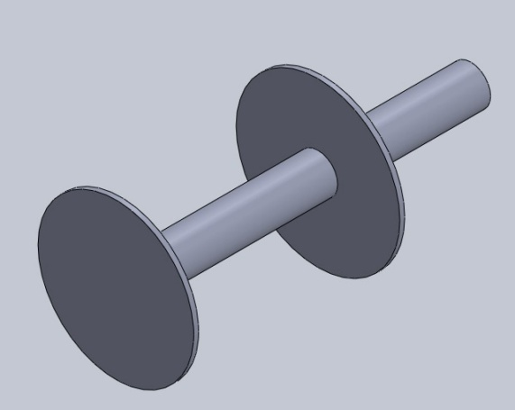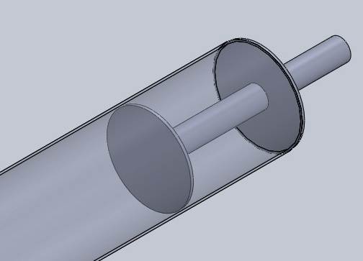

c) Motor flange- It is flange has to be welded on other side of pipe shaft. Motor drive is attached
To the pipe shaft through motor flange.

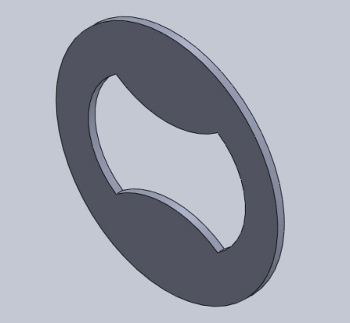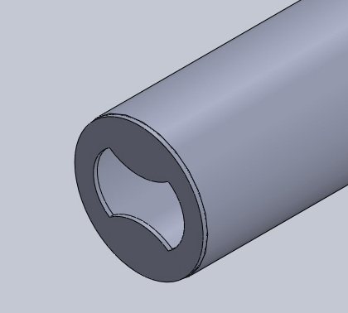

Check list for rolling shutter site

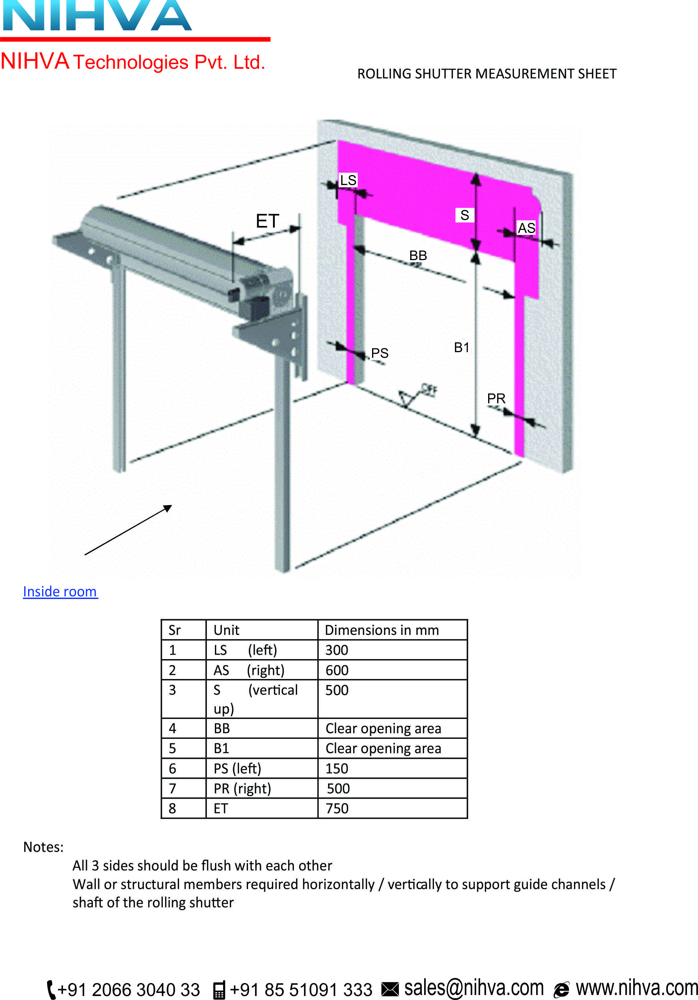

Design of rolling shutter
1. Selection for guide channel – The depth and width of the guide channel shall be as under:-
Clear width of shutter | Depth of guide as per IS6248-1979 | Depth of guide as per  NIHVA recommendation
Up to 3.5m | 65mm | 75mm
3.5m to 8m | 75mm | 100mm to 150mm
8m and above | 100mm | 150mm

2. Bracket plate - The bracket plate shall be fabricated out of mild steel of 3.15mm thickness (minimum), thicker plates may be used depending upon the height of shutter.
Clear Height in m | Size of bracket plate in mm
Up to 2.3m | 300x300x3.15
2.3 to 2.6 | 325x325x3.15
2.3 to 3.0 | 350x350x3.15
3.0 to 3.5 | 375x375x3.15
3.5 to 4.5 | 400x400x6
4.5 to 5.5 | 450x450x6
5.5 to 6.5 | 500x500x6
6.5 to 8 | 550x550x8

3. Selection for motor (indirect type Jielong make)
For motor selection we should know how much weight of the shutter. The tentative weight for shutter considered as 25kg/sq.m.
Weight of shutter = Width (in m) x height (in m) x 25kg/sq.m
For example, if W= 5m & H=5m
Then approximate weight of shutter will be = 5x5x25
= 625 kg
Then select motor from following table i.e. Jielong ECR 800
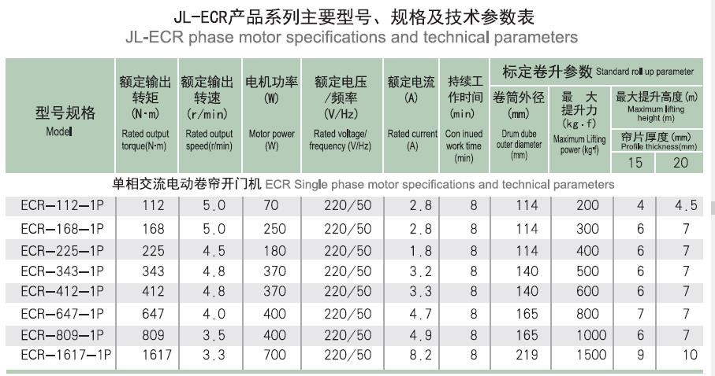
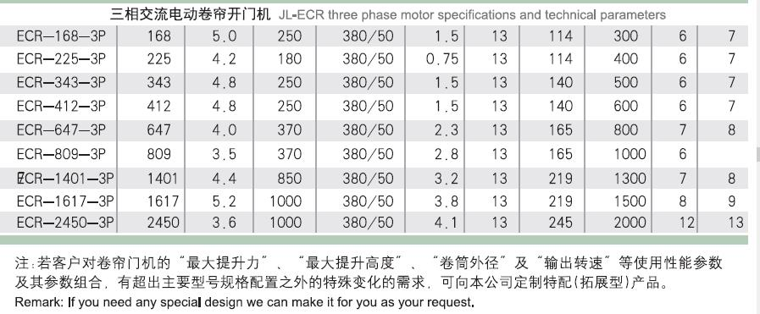
4. Selection of pipe shaft-
We can simply select pipe shaft from following table relevant to motor selection.
Nominal diameter of  Shaft/MS pipe | Outer diameter of  Pipe in mm | Maximum lifting  Capacity in kg | Nihva recommended motor(Jielong make)
(DN 100mm) 4” | 114 | 200-400 | ECR 400
(DN 125mm) 5” | 140 | 500-600 | ECR 600
(DN 150mm) 6” | 165 | 800-1000 | ECR 800/ ECR 1000
(DN 200mm) 8” | 219 | 1000 Up to 1500 | ECR1000/ECR1500
(DN 225mm) 9” | 245 | 1500-2000 | ECR2000

Let’s design a shutter of size 5m (Width) x 5m (Height) - case study for SMCC, Gujarat.
We have observed sag in shutter so let’s keep guide height 5300mm instead of 5000 to
Avoid sag in shutter.

1. Guide channel- From guide selection table we can select 100mm guide also but as per customer demand or safety purpose select 150mm guide width.
Hence, w=150mm & L=5300mm
2. Slat- Total width of shutter= Clear width + Width of both shutter
= 5000mm+ 300mm
=5300mm -100mm clearance for sliding of slat
=5200mm.
3. Bracket plate- As height of shutter is actually 5300mm then select bracket dimensions from table which is 450x450x6mm.

4. Selection of motor- first calculate the approximate weight of rolling shutter.
Weight= 5.3mx5mx25 sq.m
= 662.5kg
Then select motor from table i.e. Jielong model ECR800 capacity- 800kg

5. Bearing- In motorized rolling shutter only one bearing required at non motor side.
Generally 40mm solid bar is used for flanged shaft with two circular plate out which one will be in pipe shaft other will be welded outer surface of pipe shaft.
For 40mm shaft select - NTN CM UCF208D1 or same spec. of other make.
As we have selected DN (150mm) 6” pipe of outer diameter 168mm and inner diameter 161.5mm. So diameter of circular plates of 5mm THK. Should be 166mm & 158mm respectively.

6. Hood cover- It is the cover which is mounted on ms brackets to protect shutter and shaft assembly from water & dust. Another application of hood cover is for better
Aesthetic of shutter.

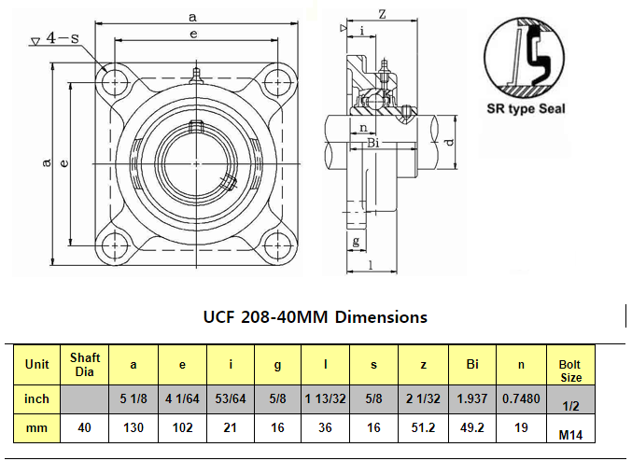

For example 1000 kg motor. We need 40 mm bearing ID.

Following drawings are attached for manufacturing of s

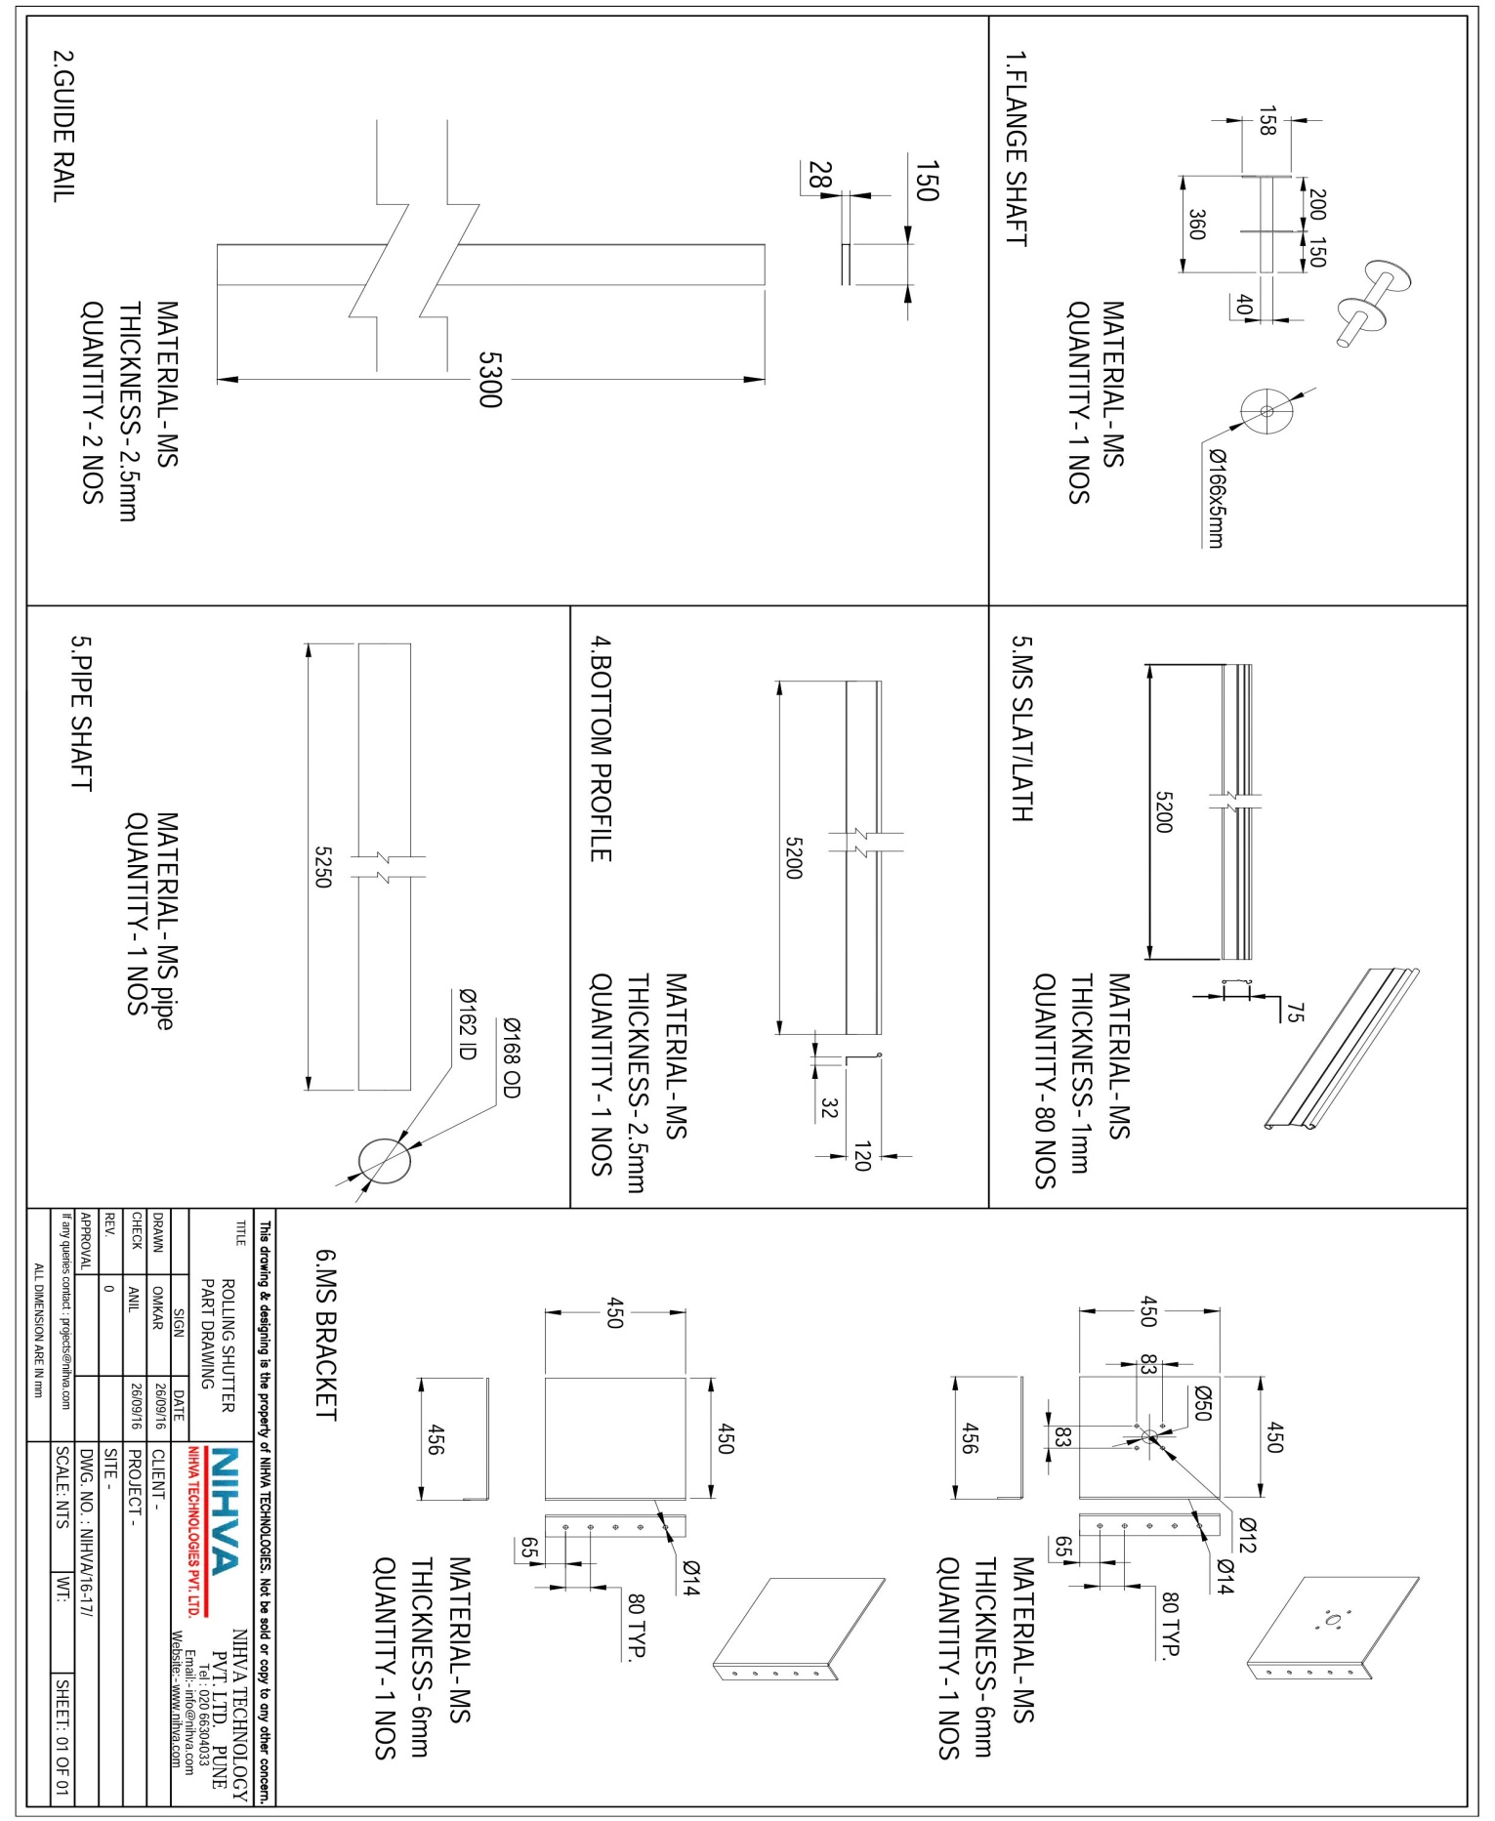
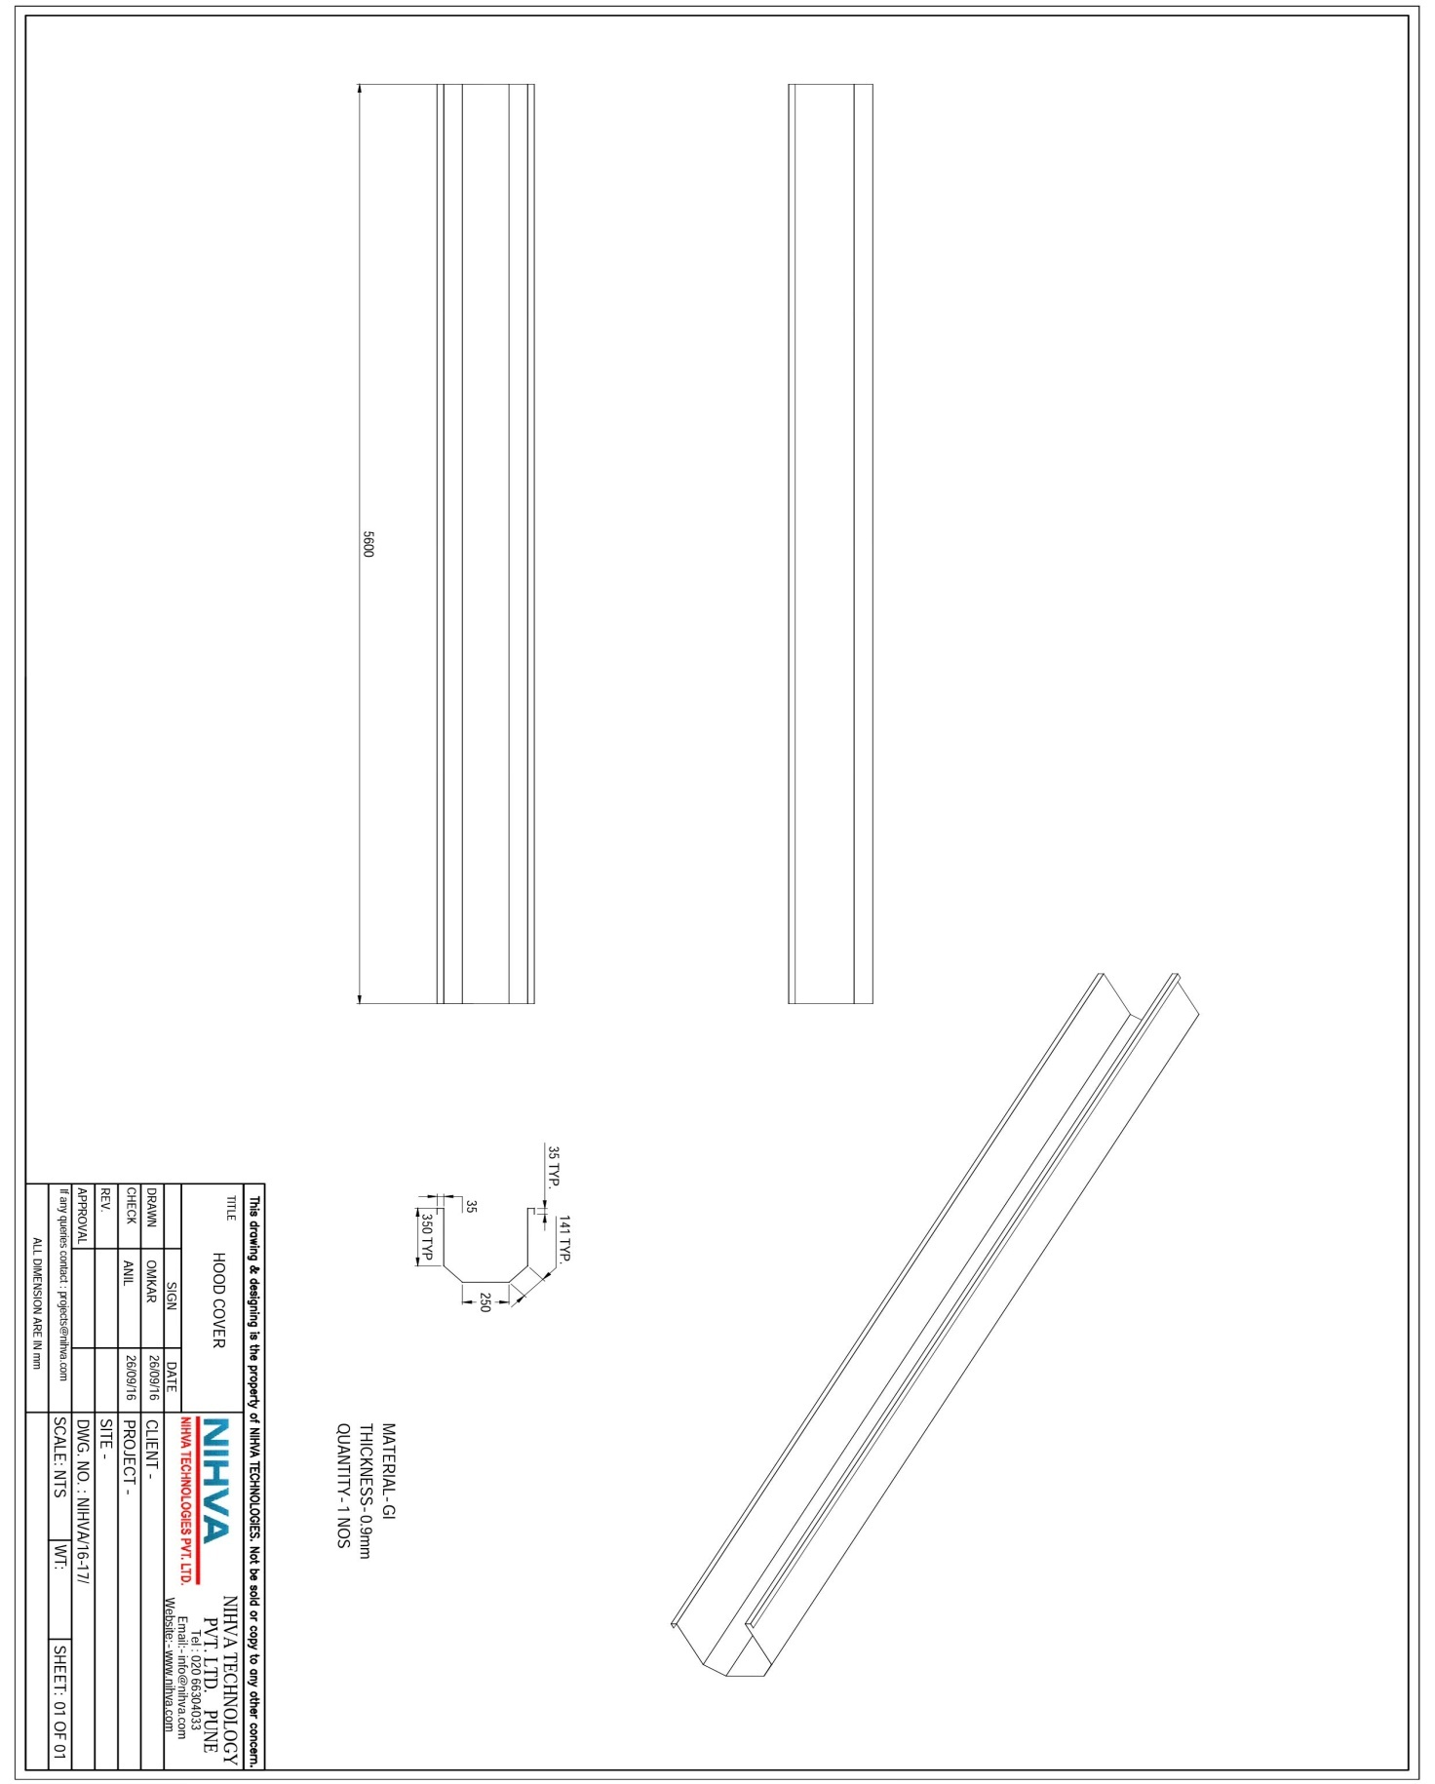
SR NO | PART NAME | MATERIAL | SPECIFICATION | QUANTITY | UNIT COST | BASIC COST | COST WITH
 |  |  |  |  |  |  | TAX& TRANS.
1 | SLAT | MS | 5200mm | 80 | 75/KG | 27000
2 | GUIDE | MS | 5300mm | 2 | 60/KG | 4200
3 | BRACKETS | MS | 450x450x6mm | 2 | 1000/PC | 2000
4 | BEARINGS | CAST IRON | NTN CM UCF208D1 | 1 | 1200/PC | 1200 | 1200
5 | FLAT | MS | 30x3000x5mm | 1
6 | SHAFT FLANGE | MS | 40mm BRIGHT BAR | 1 |  | 700
 |  |  | WITH FLANGE
7 | SHAFT PIPE | MS | 6" INCH OD-168mm | 1 |  | 3700
 |  |  | THICKNESS-3.4mm
 |  |  | LENGTH-5250mm
8 | MOTOR | JIELONG MAKE | 1000 KG | 1 |  | 13100
9 | ANCHOR F. | MS | 12X100mm | 20 |  | 480
10 | KLITS & RIVETS
11 | NUT& BOLTS | MS | M10X60 | 10 |  | 70
12
13 | GASKET | RUBBER | LENGTH-5000mm | 1 | 140/m | 700
14 | MOTOR CHAIN | STEEL | 8000mm | 1 |  | 680
15 | COATING | PAINT | RED OXIDE | 15 LIT. | 150/LIT | 2250
16 | ANGLE | MS | 35x35mm | 1
17 | HOOD COVER | GI | 5600mm | 1 |  | 4000
TOTAL COST
BILL OF MATERIAL FOR MOTORIZED ROLLING SHUTTER SIZE- 5x5m

